Part Number: 08545-00930

08545-00931

Kit Contents
Item # | Quantity Reqd. | Description
1 | 1 | Navigation System
2 | 1 | GPS Antenna
3 | 1 | Wire Harness
4 | 1 | DVD-ROM
5 | 1 | Owner’s Manual
Hardware Bag Contents
Item # | Quantity Reqd. | Description
1 | 1 | Earth Plate
2 | 2 | Cord Clamp
3 | 5 | Wire Tie
4 | 3 | Foam Tape
5 | 1 | Protection Sheet
6 | 8 | Bolt(M5×8)
7 | 1 | Double Sided Tape
Additional Items Required For Installation
Item # | Quantity Reqd. | Description
Conflicts
None
Recommended Tools
Personal & Vehicle Protection | Notes
Blankets
Masking tape
Vinyl tape
Special Tools | Notes
iPod Connector Checker Jig | Toyota P/N: SXA06-038-01
Installation Tools | Notes
Panel Clip Removal Tool | e.g. Toyota SST P/N:  00002-06002-01
Wrench | Open End, 10mm
Socket | 10mm
Ratchet
Extension
Screwdriver | Phillips
Torque Wrench | 48 lbf-in (5.4 N-m)
Pliers | Needle Nose
Scissors
Nipper
Needle-nose Pliers
Special Chemicals | Notes
None
General Applicability
Recommended Sequence of Application
Item # | Accessory
1 | Navigation System
2 | Satellite Radio
3 | Subwoofer
4 | Interior lights
5 | Remote Engine Start
6 | VIP-RS3200+
*Mandatory
Vehicle Service Parts (may be required for reassembly)
Item # | Quantity Reqd. | Description
Legend
STOP: Damage to the vehicle may occur. Do not proceed until process has been complied with.
OPERATOR SAFETY: Use caution to avoid risk of injury.
CAUTION: A process that must be carefully observed in order to reduce the risk of damage to the accessory/vehicle and to ensure a quality installation.
TOOLS & EQUIPMENT: Used in Figures calls out the specific tools and equipment recommended for this process.
REVISION MARK: This mark highlights a change in installation with respect to previous issue.
SAFETY TORQUE: This mark indicates that torque is related to safety.

Care must be taken when installing this accessory to ensure damage does not occur to the vehicle. The installation of this accessory should follow approved guidelines to ensure a quality installation.

These guidelines can be found in the "Accessory Installation Practices" document.

This document covers such items as:-
- Vehicle Protection (use of covers and blankets, cleaning chemicals, etc.).
- Safety (eye protection, rechecking torque procedure, etc.).
- Vehicle Disassembly/Reassembly (panel removal, part storage, etc.).
- Electrical Component Disassembly/Reassembly (battery disconnection, connector removal, etc.).

Please see your Toyota dealer for a copy of this document.

Protect the Vehicle.
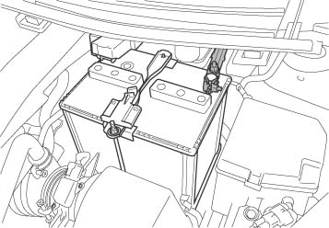
  - Remove the negative battery cable (Fig. 1-1).
Ratchet, 10mm socket
Negative Battery Cable
Battery

Fig. 1-1
    - Protect the fender before starting.
    - Do not touch the positive terminal with any tools when removing the cable.

Disassemble the Vehicle.
NOTE: Place all removed parts on a protected surface.
NOTE: When disconnecting wiring connectors, do NOT pull on the wiring, pull on the connector only.
NOTE: Engage the parking brake while working.
  - Remove the instrument panel cluster finish center panel.
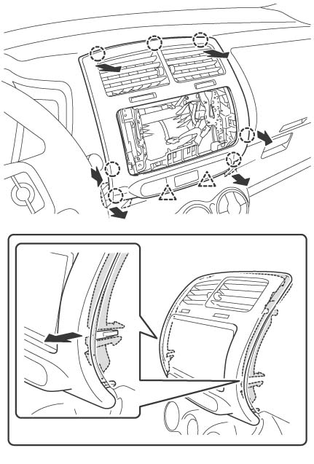
    - Disengage the 2 claws and 7 clips and remove the instrument panel cluster finish center panel (Fig. 2-1).
Fig. 2-1
Instrument panel cluster finish center panel

B

C

B

A

Clips (×7)

Fig. 2-1a

Claws (×2)

A

Clip B

Retainer

    - Disconnect the connector and put a mark on it.
NOTE: Disengage the clips in the order A to C as shown in the illustration.
NOTE: Remove the instrument panel cluster finish center panel while preventing the retainer from separating from the vehicle (Fig. 2-1a).

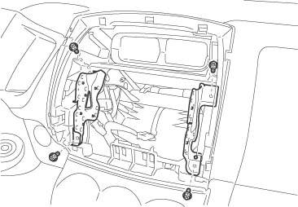
  - To remove the radio brackets (L and R), remove the 4 screws (Fig. 2-2).
Fig. 2-2
Radio bracket (L)
Screw (×4)
Phillips screwdriver
Radio bracket (R)

  - Remove the meter cluster panel.
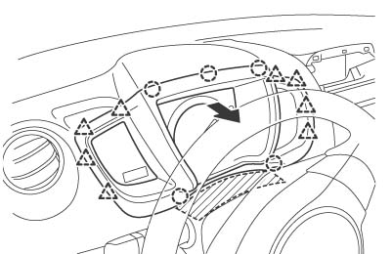
    - Apply masking tape to the upper side of the steering column upper cover (Fig. 2-3).
Fig. 2-3
Meter cluster panel
Claw (×8)
Steering column upper cover
Masking tape
Clip (×5)
A
B
B
C
C
    - Tilt the steering column down and push the wiper lever down.
    - Disengage the 8 claws and 5 clips in the order A to C and remove the meter cluster panel (Fig. 2-3).
  - Remove the combination meter assembly.
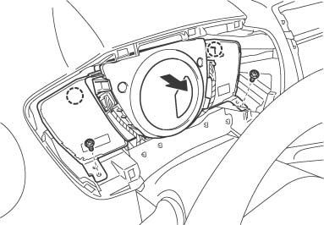
    - Remove the 2 screws, disengage the 2 clips and remove the combination meter assembly (Fig. 2-4).
Phillips screwdriver
Fig. 2-4
Clip (×2)
Screw (×2)
Combination meter assembly
    - Disconnect the connectors (Fig. 2-4).

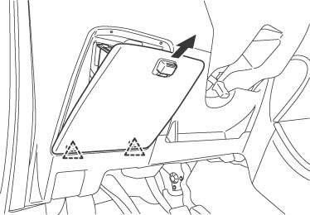
  - Disengage the 2 claws and remove the instrument panel box (Fig. 2-5).
Fig. 2-5
Instrument panel box
Claw (×2)

  - Remove the front pillar garnish (L).
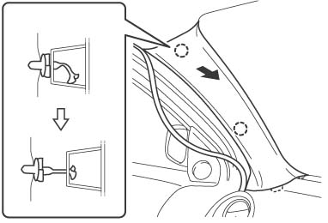
    - Disengage the 2 clips from the vehicle (Fig. 2-6).
Fig. 2-6
Front pillar garnish (L)
Clip B
Clip A
Clip B
    - Pull the front pillar garnish so that the tip of clip B locks in the front pillar garnish hole (Fig. 2-6).

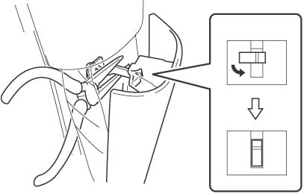
    - Wrap the jaws of needle-nose pliers with masking tape to prevent damage and rotate clip B 90° (Fig. 2-7).
Fig. 2-7
Clip B
Front pillar garnish (L)
Needle-nose pliers with masking tape

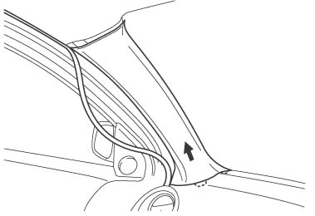
    - Pull the front pillar garnish (L) in the direction of the arrow (Fig. 2-8).
Fig. 2-8
Front pillar garnish (L)
NOTE: If clip B is damaged (i.e. scarred) or removed from the body, install a new clip B on the front pillar garnish (L). Confirm the latest clip part number on the electronic parts catalog.

Install the Navigation System.
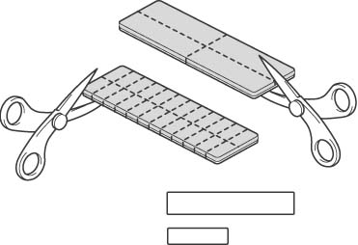
  - Cut the foam tape into 4 large pieces and 24 small pieces (Fig. 3-1).
Fig. 3-1
Scissors

Foam tape
×4
×24
<Large pieces>
・Used to bundle excess antenna cord
and wire harness.
<Small pieces>
・Used to fix the antenna cord.
・Used to fix the REV signal wire.
・Used to fix the PKB signal wire.
・Used to fix the video cord.
・Used to wrap around the antenna cord.
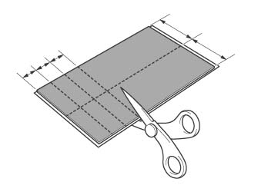
  - Cut the protection sheet into six pieces (Fig. 3-2).
Fig. 3-2
Scissors

Protection sheet
20mm
20mm
20mm
50mm
50mm
Protection sheet (20×50mm) ×6

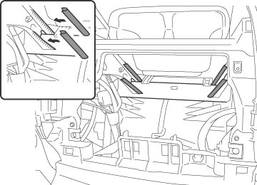
  - Apply the pieces of the protection sheet to the reinforcement (Fig. 3-3).
Fig. 3-3
Protection sheet (20×50mm)
Edge
Protection sheet (20×50mm) ×4
Reinforcement
NOTE: Before attaching the protection sheet, wipe off any dirt, water or oil from the attachment surface.

  - Cut the SPD signal wire.
    - Take the wire harness out of the kit.
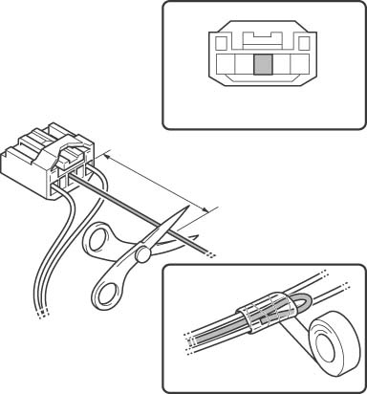
    - Cut the SPD signal wire (violet / white) from the wire harness to approximately 50mm (Fig. 3-4).
Fig. 3-4
Scissors

SPD signal wire (violet / white)
Vinyl tape
Insulation
Approx.
50mm
5P on the wire harness side
    - Wrap the SPD signal wire (violet / white) with vinyl tape (Fig. 3-4).
NOTE: It is not necessary to use the SPD signal wire (violet / white) from the wire harness

  - Remove the radio harness and antenna cable.
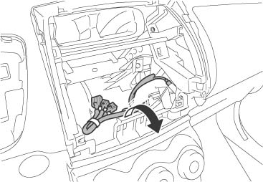
    - Remove the tape securing the radio harness (Fig. 3-5).
Fig. 3-5
Radio harness
Antenna cable
Tape
    - Pull the antenna cable out from the instrument panel hub (Fig. 3-5).

  - Install and route the GPS antenna.
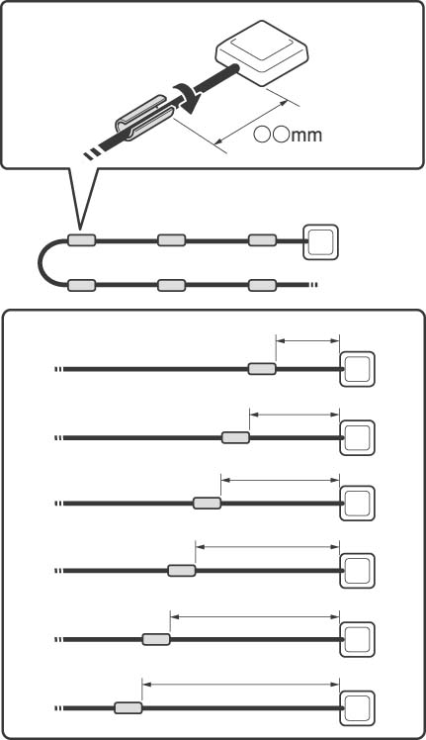
    - Wrap pieces of foam tape around the specified areas of the antenna cord (Fig. 3-6).
Fig. 3-6
Antenna cord
GPS antenna
60mm
GPS antenna
Foam tape
Foam tapes (×6)
230mm
400mm
570mm
740mm
910mm

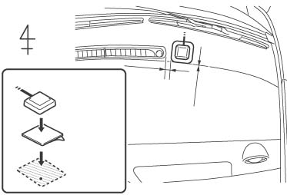
    - Remove the release paper from the earth plate and attach the earth plate onto the attachment (Fig. 3-7).
Fig. 3-7
Top view
0mm

Front

Earth plate

10mm

GPS antenna

Earth plate

Earth plate attachment position

    - Place the GPS antenna onto the center of the earth plate (Fig. 3-7).
NOTE: Before attaching the earth plate, wipe off any dirt, water or oil from the attachment surface.

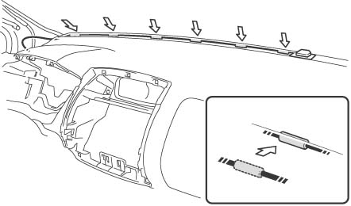
    - Route the antenna cord to the front pillar (L) and fit it into the clearance between the dashboard and the windshield
(Fig. 3-8).
Fig. 3-8
Antenna cord
GPS antenna
Foam tape
Clearance

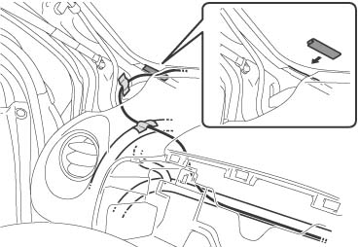
    - Apply the piece of the protection sheet to the area indicated by A (Fig. 3-9).
Fig. 3-9
Protection sheet (20×50mm)

Foam tapes (×2)

A

Antenna cord

Vehicle wire harness

    - Route the antenna cord and fix it to the front pillar body surface and the vehicle wire harness with foam tape (Fig. 3-9).

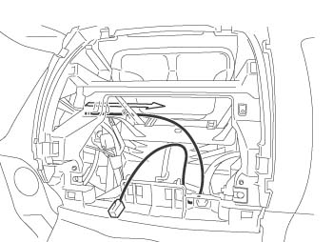
    - Temporaily route the antenna cord to the navigation system installation location (Fig. 3-10).
Fig. 3-10
Antenna cord

  - Route the wire harness.
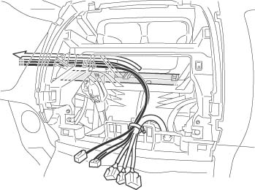
    - Fix the wire harness and antenna cord to the vehicle wire harness with a wire tie
(Fig. 3-11).
Fig. 3-11
Wire tie

Radio harness

Antenna cord

PKB signal wire (red / white)

REV signal wire (green)

Vehicle wire harness

Wire harness

    - Route the PKB signal wire (red / white) and REV signal wire (green) from the wire harness along the vehicle wire harness to the vicinity of combination meter (Fig. 3-11).

  - Temporarily route the PKB signal wire and REV signal wire.
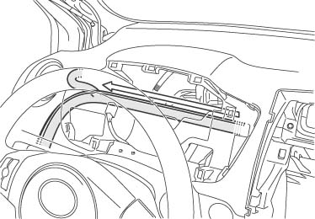
    - Temporarily route the REV signal wire (green) and the PKB signal wire (red / white) from the wire harness along the vehicle wire harness (Fig. 3-12).
Fig. 3-12
PKB signal wire (Red / White)

REV signal wire (Green)

Vehicle wire harness

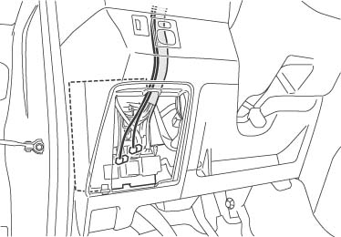
    - Temporarily route the REV signal wire (green) and the PKB signal wire (red / white) from the wire harness along the vehicle wire harness to the instrument panel J/B (Fig. 3-13).
Fig. 3-13
PKB signal wire (red / white)

REV signal wire (green)

Vehicle wire harness

Instrument panel J/B

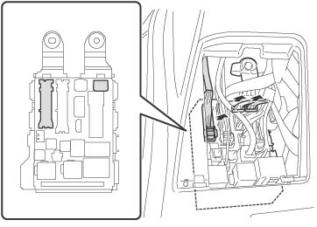
    - Disconnect the white 16P connector and white 30P connector from the instrument panel J/B (Fig. 3-14).
Fig. 3-14
Front view

Instrument panel J/B

30P (white)

Instrument panel J/B

16P (white)

14P (white)

NOTE: If it is hard to disconnect the white 16P connector, disconnect the white 14P connector first.

  - Connect the PKB signal wire.
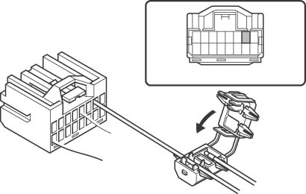
    - Connect the yellow wire (7th pin from the top left) from the white 16P connector to the PKB signal wire (red / white) from the wire harness (Fig. 3-15).
Fig. 3-15
16P (white)

Vehicle wire harness
(yellow)

PKB signal wire (red / white)

Splicing connector

16P on the wire harness side

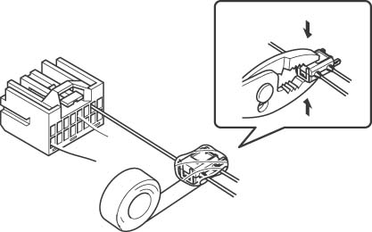
    - Use pliers to engage the splicing connector (Fig. 3-16).
Fig. 3-16
16P (white)

Splicing connector

Pliers

Pliers

    - Wrap vinyl tape around the splicing connector (Fig. 3-16).
    - Reconnect the white 16P connector
(Fig. 3-16).

  - Connect the REV signal wire.
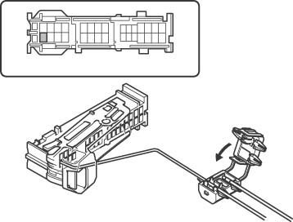
    - Connect the red wire (1st pin bottom row from left) from the white 30P connector to the REV signal wire (Green) from the wire harness (Fig. 3-17).
Fig. 3-17
30P (white)

Vehicle wire harness (red)

REV signal wire (green)

Splicing connector

30P on the wire harness side

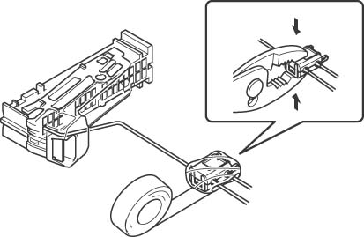
    - Use pliers to engage the splicing connector (Fig 3-18).
Fig. 3-18
30P (white)

Pliers

Vinyl tape

Pliers

Splicing connector

    - Wrap vinyl tape around the splicing connector (Fig. 3-18).
    - Reconnect the white 30P connector
(Fig. 3-18).
  - Fix the REV signal wire and PKB signal wire.
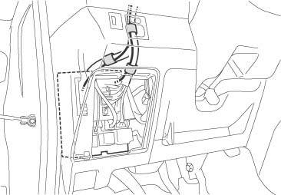
    - Take the REV signal wire (green) and PKB signal wire (red / white) from the wire harness and fix them to the vehicle wire harness with foam tape (Fig. 3-19).
Fig. 3-19
REV signal wire (green)

Vehicle wire harness

Foam tape (×3)

PKB signal wire (red / white)

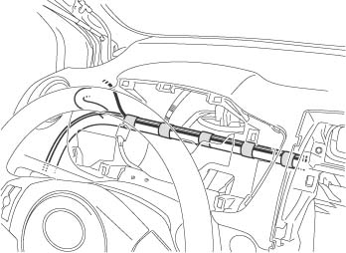
    - Take the antenna cord, REV signal wire (green) and PKB signal wire (red / white) from the wire harness and fix them to the vehicle wire harness with foam tape (Fig. 3-20).
Fig. 3-20
Vehicle wire harness

Foam tape (×5)

Antenna cord

PKB signal wire (Red / White)

REV signal wire (green)

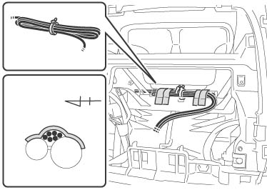
  - Bundle the wire harness and antenna cord with the 2 wire ties and fix them to the vehicle wire harness with foam tape (Fig. 3-21).
Fig. 3-21
Wire tie

Front

Cross sectional view

Wire tie (×2)

Foam tape (×4)

Reinforcement

Vehicle wire harness

Antenna cord

Wire harness

  - Fix the video cord.
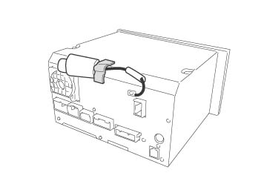
    - Remove the vinyl covering from the video cord (Fig. 3-22).
Fig. 3-22
Navigation system

Foam tape

Video cord

    - Fix the video cord to the navigation system with foam tape (Fig. 3-22).

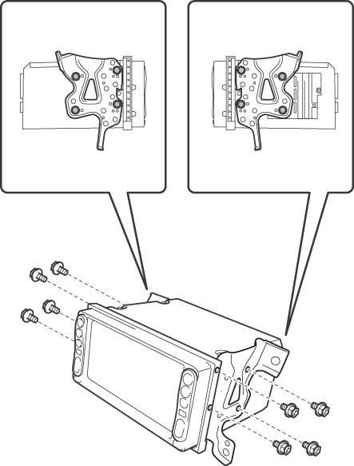
  - Install the brackets (L and R) onto the navigation system with the 8 bolts (M5×8) (Fig. 3-23).
Fig. 3-23
Right side view

Left side view

Phillips Screwdriver

Radio bracket (R)

Radio bracket (L)

Navigation system

Bolt (M5×8) (×8)

  - Install the navigation system.
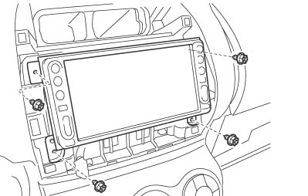
    - Connect the connectors (20P /16P /10P / 6P / wire harness / GPS antenna cable / radio antenna cable) to the navigation system (Fig. 3-24).
Fig. 3-24
Phillips screwdriver

Navigation system

Screw (×4)

NOTE: The clock/hazard uses a similar 12 pin connector as the navigation system. It is possible to connect the clock connector into AVC-LAN connector of the navigation system by mistake. The result will blow the dome fuse.
    - Install the navigation system with the 4 bolts (Fig. 3-24).
  - Reinstall the parts in the reverse order of removal.

Perform an In-Process Function Check - Check the REV/PKB Signal Wire Connection.
  - Reconnect the vehicle’s negative battery
Torque wrench, 10mm Socket

Fig. 4-1
Battery
Negative battery
cable
cable (Fig. 4-1).
    - Position the negative terminal back to the factory position.
    - Tighten the nut to 48 in-lbs (5.4 N-m).
Torque: 48 in-lbs (5.4 N-m)
    - Do not touch the positive terminal with
any tools when replacing the cable.
  - Connect the dome fuse.
  - Install the navigation DVD.

  - Press the "DISP" button to display the initial search screen. (Fig. 4-2).
Fig. 4-2

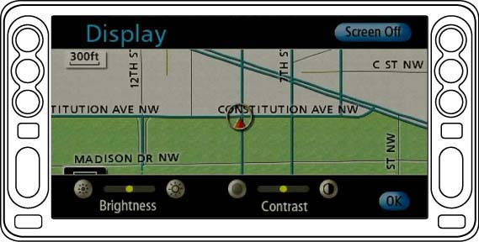
  - In order to display the "System Check Mode" screen, touch areas A and B, indicated on the screen, in the following order:
A→B→A→B→A→B･･････(Fig. 4-3).
Fig. 4-3
A
B

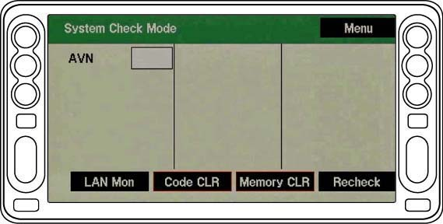
  - Touch "Menu" to display the Diagnosis Menu screen (Fig. 4-4).
Fig. 4-4

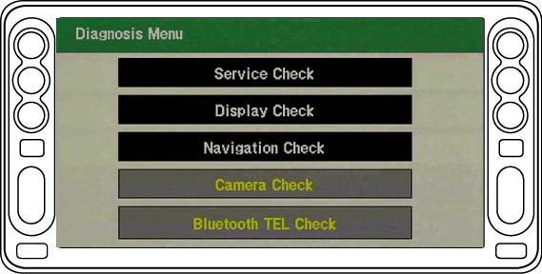
  - Touch "Display Check" to display the Display Check screen (Fig. 4-5).
Fig. 4-5

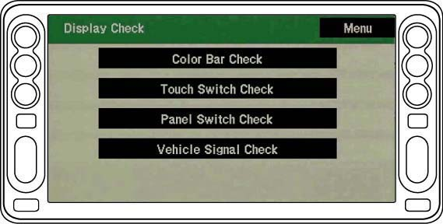
  - Touch "Vehicle Signal Check" to display the Vehicle Signal Check screen (Fig. 4-6).
Fig. 4-6

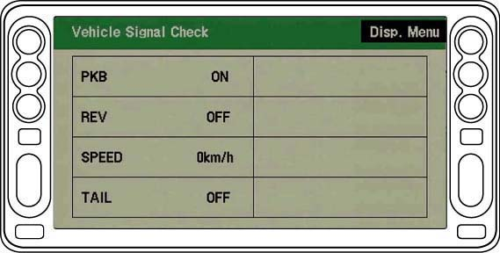
  - Perform the following confirmation tests by referring to the indications circled on the screen (Fig. 4-7).
Fig. 4-7
PKB
    - When the PKB is engaged →ON
    - When the PKB is disengaged →OFF
REV
    - When the shift lever is engaged in the R position →ON
    - When the shift lever is engaged in any position other than R →OFF
NOTE: If the results are not as specified, check the connection again.

  - Terminate the operation by pressing the "DISP" button on the screen for more than 3 seconds (Fig. 4-8).
Fig. 4-8

iPod Check Procedure (PORT INSTALL ONLY – NOT REQUIRED FOR DEALERS).
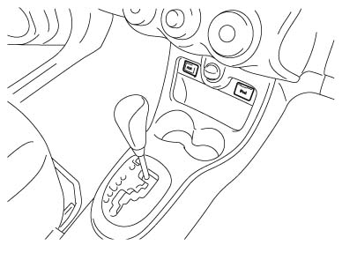
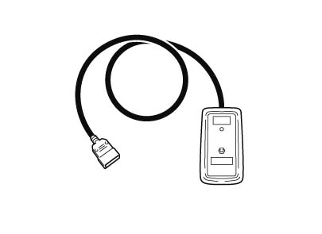
  - Connect the iPod Connector Checker Jig
(Fig. 5-2) to the vehicle’s iPod Connector (Fig. 5-1).
Fig. 5-1
iPod Connector

Fig. 5-2
iPod Connector Checker Jig,
Toyota P/N SXA06-038-01

  - Turn on the ACC switch.
  - Push the iPod Checker Switch on the iPod Connector Checker Jig.
  - Check the LED. The LED should turn on to green. If no LED is on, then the iPod Connector is NG.
  - Turn off the ACC switch.
  - Disconnect the iPod Connector Checker Jig from the Vehicle’s iPod Connector.

NOTE: The iPod Connector Checker Jig is powered by two AA batteries, which must be replaced periodically. Life expectancy of the batteries is approximately 6 months (or approximately 12,000 vehicles).

Complete the Installation.
  - Complete the reassembly of the vehicle.
    - Reconnect any disconnected connectors.
    - Verify the panels fit together properly
with no uneven gaps between them.
  - Clean up and remove any trash.
  - Place the owner’s manual left in their protective bags, iPod cable and DVD Jewel case in the glove box.

Accessory Function Checks
Press the “MENU” button and check that the menu screen appears.
Touch the “Volume” button and check that the volume level displayed on the volume screen changes accordingly.
Press the “MAP/VOICE” button and check that the map screen appears.
Touch and scroll the map displayed on the screen and check that the map can be scrolled.
Check for the GPS icon on display when under open sky.

Vehicle Function Checks
Hazard Switch
Air Conditioner
Front Passenger Seat Belt Monitor
Door Key Lock Monitor
Cigarette Lighter
Refer to your Car Owner’s Manual, and
return the Power Windows to their initial
positions.
Refer to your Car Owner’s Manual, and
return the Back Door Lock to its initial
position.
Steering Wheel Audio Controls
TRAC, TPMS and Combination Meter, Parking Brake and Reverse

GPS antenna connection is ok
Functioning Hazard Switch
Functioning Air Conditioner
Functioning Front Passenger Seat Belt Monitor
Functioning Door Key Lock Monitor
Functioning Cigarette Lighter
Auto-open and Auto-close operation of each of the Power Windows is possible with the driver’s seat master switch.
Door Lock and Unlock functions operate
correctly.
Volume, Mode and Seek function
Ensure LED operation

